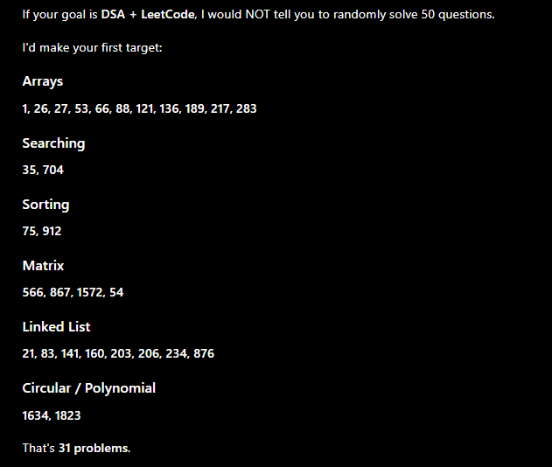

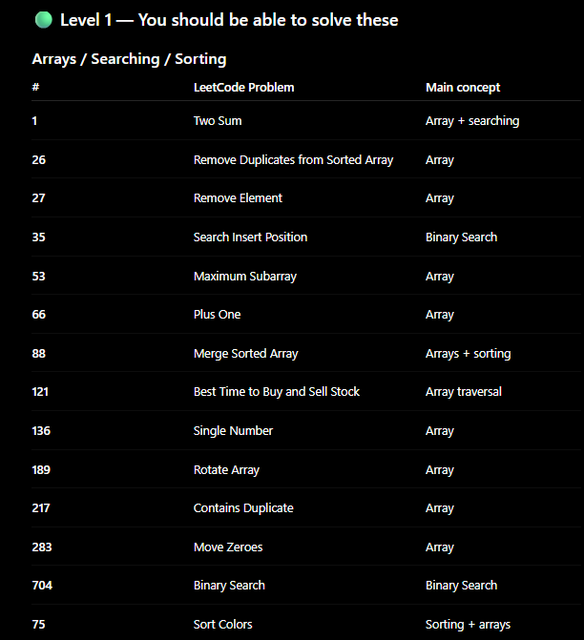
DONE:
1 26
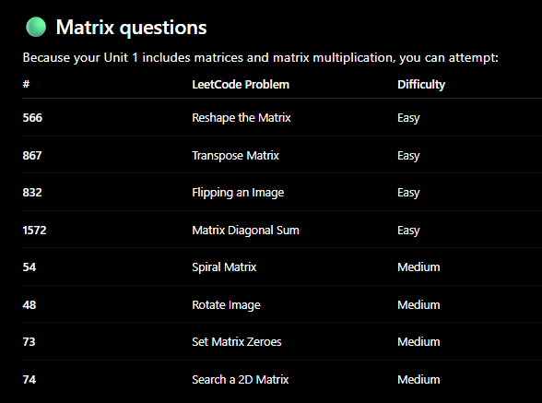

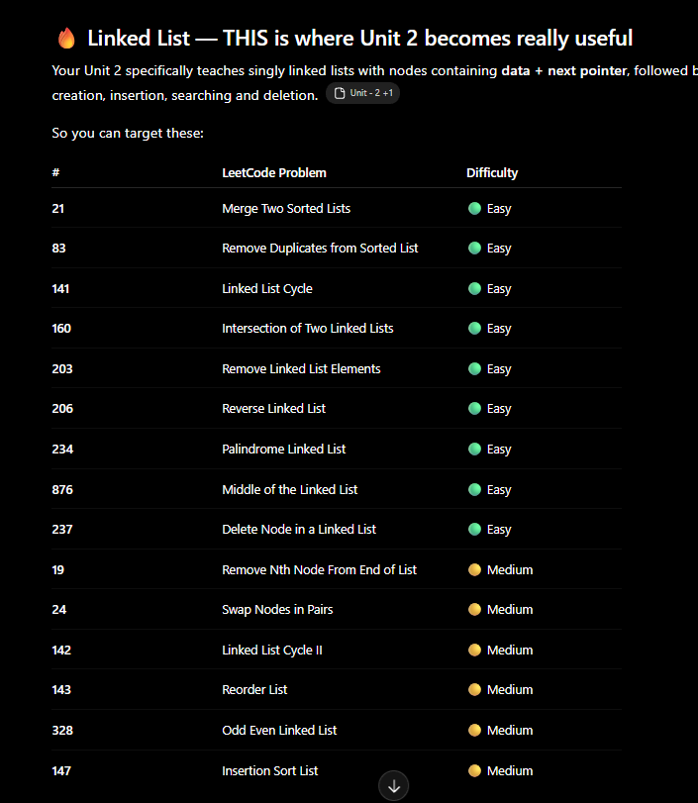

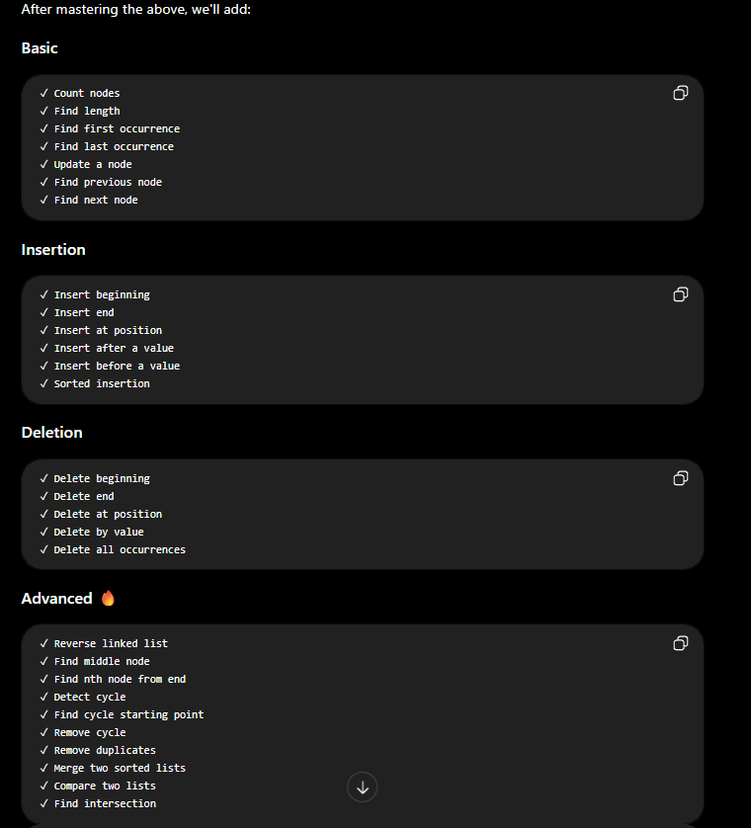

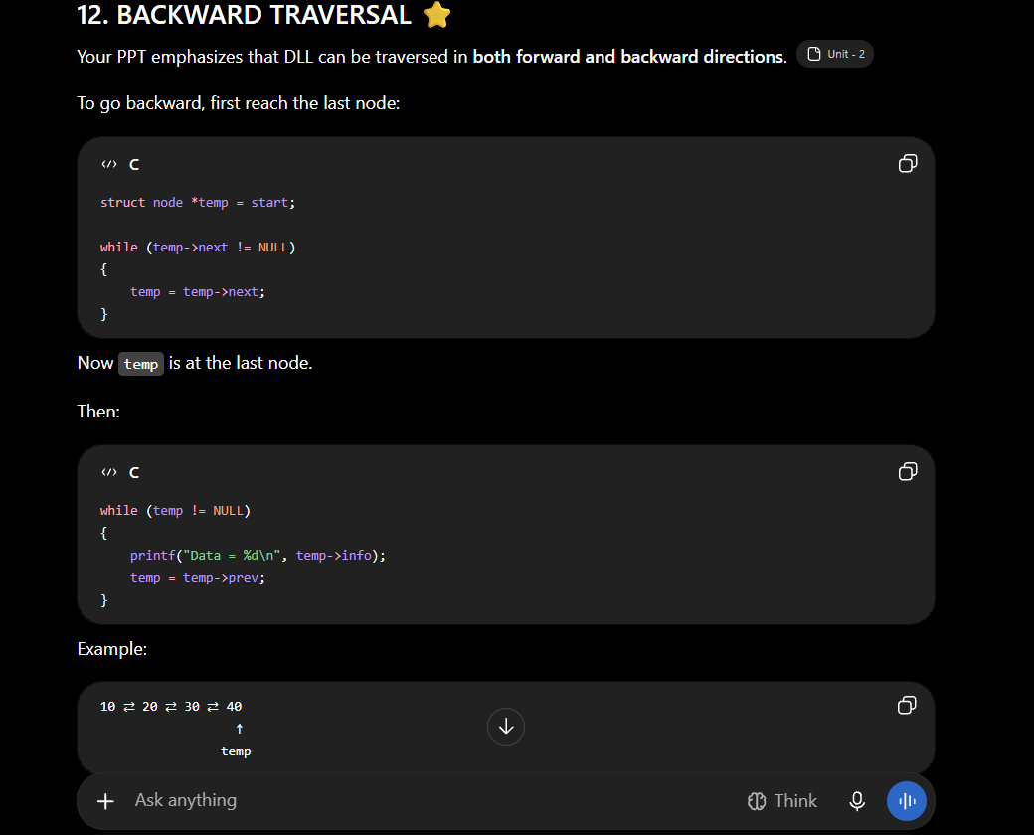

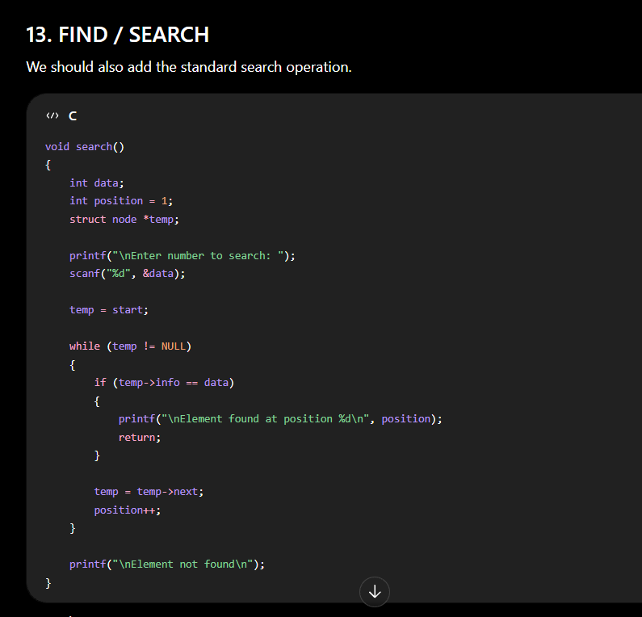

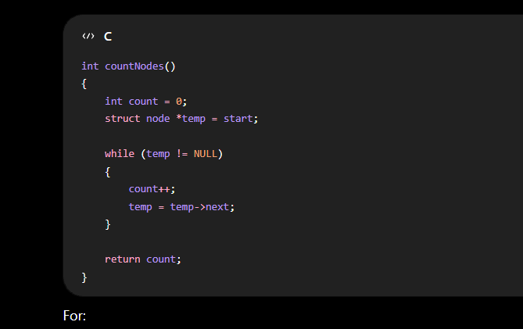

# | LeetCode | Problem | Difficulty | Category | Concepts you need before solving
1 | #206 | Reverse Linked List | 🟢 Easy | Linked List | Pointers, SLL traversal, prev/curr/next, in-place modification
2 | #21 | Merge Two Sorted Lists | 🟢 Easy | Linked List | SLL, pointers, sorted order, comparing nodes
3 | #234 | Palindrome Linked List | 🟢 Easy | Linked List | Linked List, two pointers, slow/fast pointer, reverse list
4 | #121 | Best Time to Buy and Sell Stock | 🟢 Easy | Array | Array traversal, minimum-so-far, maximum, O(n) thinking
5 | #283 | Move Zeroes | 🟢 Easy | Array / Two Pointer | Two pointers, in-place array modification, swapping
6 | #2 | Add Two Numbers | 🟡 Medium | Linked List | SLL, pointers, carry, digit-by-digit addition
7 | #19 | Remove Nth Node From End of List | 🟡 Medium | Linked List / Two Pointer | SLL, two pointers, gap between pointers
8 | #24 | Swap Nodes in Pairs | 🟡 Medium | Linked List | Pointer manipulation, previous/current/next
9 | #92 | Reverse Linked List II | 🟡 Medium | Linked List | SLL reversal, pointer manipulation, sublist boundaries
10 | #61 | Rotate List | 🟡 Medium | Linked List | SLL traversal, length, tail/head manipulation
11 | #86 | Partition List | 🟡 Medium | Linked List | Multiple linked lists, pointers, preserving order
12 | #328 | Odd Even Linked List | 🟡 Medium | Linked List | Pointer jumping, rearranging nodes, in-place manipulation
13 | #143 | Reorder List | 🟡 Medium | Linked List | Slow/fast pointer, middle finding, reverse list, merge lists
14 | #142 | Linked List Cycle II | 🟡 Medium | Linked List / Two Pointer | Fast/slow pointer, cycle detection, pointer mathematics
15 | #148 | Sort List | 🟡 Medium | Linked List / Sorting | Merge sort, linked list splitting, merging sorted lists, recursion
16 | #15 | 3Sum | 🟡 Medium | Array / Two Pointer | Sorting, two pointers, duplicate handling, nested logic
17 | #11 | Container With Most Water | 🟡 Medium | Array / Two Pointer | Two pointers, greedy thinking, eliminating unnecessary searches
18 | #75 | Sort Colors | 🟡 Medium | Array / Two Pointer | In-place sorting, two/three pointers, Dutch National Flag
19 | #238 | Product of Array Except Self | 🟡 Medium | Array / Prefix-Suffix | Prefix products, suffix products, O(n), O(1) extra space
20 | #33 | Search in Rotated Sorted Array | 🟡 Medium | Array / Binary Search | Binary search, sorted portions, index manipulation
21 | #153 | Find Minimum in Rotated Sorted Array | 🟡 Medium | Array / Binary Search | Binary search, sorted vs rotated portions
22 | #74 | Search a 2D Matrix | 🟡 Medium | Matrix / Binary Search | 2D arrays, matrix indexing, binary search
23 | #56 | Merge Intervals | 🟡 Medium | Array / Sorting | Sorting, intervals, overlap detection, merging
24 | #73 | Set Matrix Zeroes | 🟡 Medium | Matrix / In-Place | 2D arrays, matrix traversal, O(1) extra-space thinking
25 | #54 | Spiral Matrix | 🟡 Medium | Matrix | Matrix traversal, boundaries, direction changes
26 | #25 | Reverse Nodes in k-Group | 🔴 Hard | Linked List | Linked List reversal, groups, pointer manipulation, recursion/iteration
27 | #42 | Trapping Rain Water | 🔴 Hard | Array / Two Pointer | Two pointers, prefix/suffix maximum, optimization
28 | #41 | First Missing Positive | 🔴 Hard | Array / In-Place | Array indexing, in-place marking, O(n) reasoning
29 | #4 | Median of Two Sorted Arrays | 🔴 Hard | Array / Binary Search | Binary search, sorted arrays, partitioning, mathematical reasoning
30 | #23 | Merge k Sorted Lists | 🔴 Hard | Linked List / Advanced | Linked lists, merging, divide & conquer / heap

